MicroGrids REsource Assessment

Prepared by:
Hannah Mankle, Oregon State University
Bryson Robertson, Oregon State University*
*bryson.robertson@oregonstate.edu

Contents
1 Introduction 2
2 Wave Resource Results 3
2.1 PacWave South, OR assessment 3
2.1.1 Annual histogram of sea state occurrences 3
2.1.2 Annual wave Rose 4
2.1.3 Annual variation of long-term monthly mean 5
2.1.4 Extreme Environmental contours 7
2.1.5 Key resource parameters 8
2.2 Wave Energy Testing Site, HI assessment 9
2.2.1 Annual histogram of sea state occurrences 9
2.2.2 Annual wave Rose 10
2.2.4 Extreme Environmental contours 13
2.2.5 Key resource parameters 13
2.3 Molokai, HI assessment 14
2.3.1 Annual histogram of sea state occurrences 14
2.3.2 Annual wave Rose 15
2.3.3 Annual variation of long-term monthly mean 16
2.3.4 Extreme Environmental contours 18
2.3.5 Key resource parameters 18
2.4 St. Paul, AK assessment 19
2.4.1 Annual histogram of sea state occurrences 20
2.4.2 Annual wave Rose 20
2.4.3 Annual variation of long-term monthly mean 21
2.4.4 Extreme Environmental contours 23
2.4.5 Key resource parameters 24
2.5 Yakutat, AK assessment 25
2.5.1 Annual histogram of sea state occurrences 25
2.5.2 Annual wave Rose 26
2.5.3 Annual variation of long-term monthly mean 28
2.5.4 Extreme Environmental contours 28
2.5.5 Key resource parameters 29
2.6 Sebastian, FL assessment 30
2.6.1 Annual histogram of sea state occurrences 30
2.6.2 Annual wave Rose 31
2.6.3 Annual variation of long-term monthly mean 31
2.6.4 Extreme Environmental contours 33
2.6.5 Key resource parameters 34
3 References 35

1 Introduction
Six resource assessments are discussed in this report. Locations chosen are described in more detail in the following sections and are as follows:
• PacWave South (PWS), OR
• Wave Energy Testing Site (WETS), HI
• Molokai, HI
• St. Paul, AK
• Yakutat, AK
• Sebastian, FL

The dataset used in this assessment is a high-resolution, open-source Hindcast dataset from the DOE Water power technology office (WPTO) US Wave dataset [1]. For all of the locations assessed, the 3-hour resolution datasets were used. The datasets for the West Coast and Hawaii span the US Exclusive Economic Zone (EEZ) with an unstructured grid of ~ 200 m resolution in shallow water. The Alaskan coastline also covers the EEZ of the Southern Coast and the Aleutian Islands. The unstructured grid in this case is ~300 m [2]. Assessments further North than the data provided in this assessment due to the inability to collect data during the winter months when ice is present. The East Coast dataset is created from an unstructured grid that spans the entire Coast. In contrast to the West Coast, the continental shelf is much wider and shallower on the East Coast. The resolution for this data is also ~200 m [3]. The Marine and Hydrokinetic Toolkit (MHKiT) was used in conjunction with the Hindcast dataset to process and analyze the resource data. MHKiT is developed in collaboration between the National Renewable Energy Laboratory (NREL), Pacific Northwest National Laboratory (PNNL), and Sandia National Laboratories (SNL). The toolkit provides robust and verified functions that are needed when completing calculations and visualizations that adhere to International Electrotechnical Commission (IEC) technical specifications and other guidelines [4]. The functionality used in this assessment is their resource tools and data quality for wave applications. The IEC technical standard followed in this assessment is IEC Technical Specification 62600:101 [TS 62600-101]. Ten years or more of data is required to meet the IEC. Additionally, Annual monthly means, standard deviations, percentiles, and variations of all wave parameters are required. A bivariate histogram and a wave rose are also required in the assessment. If the average current speed exceeds 1.5 m/s its effect on the wave climate should be investigated and included in the wave modeling. A bivariate histogram and a wave rose are also required in the assessment. If the average current speed exceeds 1.5 m/s its effect on the wave climate should be investigated and included in the wave modeling.
The parameters that are required based on this IEC standard are the significant wave height, energy period, omnidirectional wave power (directionally unresolved wave power), directionally resolved wave power, directionality coefficient, spectral width, and mean water depth. The DOE Hindcast database provides all but the directionally resolved wave power. The directionality coefficient is the ratio of the maximum directionally resolved wave energy transport to the omnidirectional wave energy transport. This max directionally resolved wave energy transport will be used in place of the directionally resolved wave power.
Extreme condition analysis is not required by IEC TS 62600-101 for wave assessment but are required for marine energy converter design under IEC TS 6200-2. IEC TS 61400-3-2 also require extreme conditions quantification for floating wind turbine design. The contours for this analysis represent the joint probability of significant wave height and energy period with specified return periods. In this case, we are interested in return periods of 50- and 100- year return periods.

2 Wave Resource Results

2.1 PacWave South, OR assessment
The Pacific Northwest of the US has one of the most active wave climates in the world. This provides opportunities for future wave energy development. Oregon specifically seeks to be a location for testing and innovation with the construction of the PacWave South open-ocean wave energy test site. This grid-connected, 20 MW, 5-berth test facility is being developed in partnership with the US Department of Energy, the State of Oregon, Oregon State University (OSU) and local stakeholders. The facility is located at 44°35'04"N 124°12'45"W which is 11 k (~7miles) off the coast of Newport, Oregon. This assessment includes data from 1979-2010.

2.1.1 Annual histogram of sea state occurrences
To show the annual mean wave resource characteristics, a bivariate histogram of significant wave height, $H_{m0}$, and energy period, $T_{e}$, is used. The numbers in each cell represent the mean annual hours recorded in each specific $H_{m0}$ – $T_{e}$ sea state combination. Figure 1 shows the bivariate histogram where the resolution of $H_{m0}$ is 0.5 m and $T_{e}$ is 1 s. Using the Hindcast data we find the most frequent sea state, at 234 hours, has a significant wave height of 1.5 m and an energy period of 9 s.
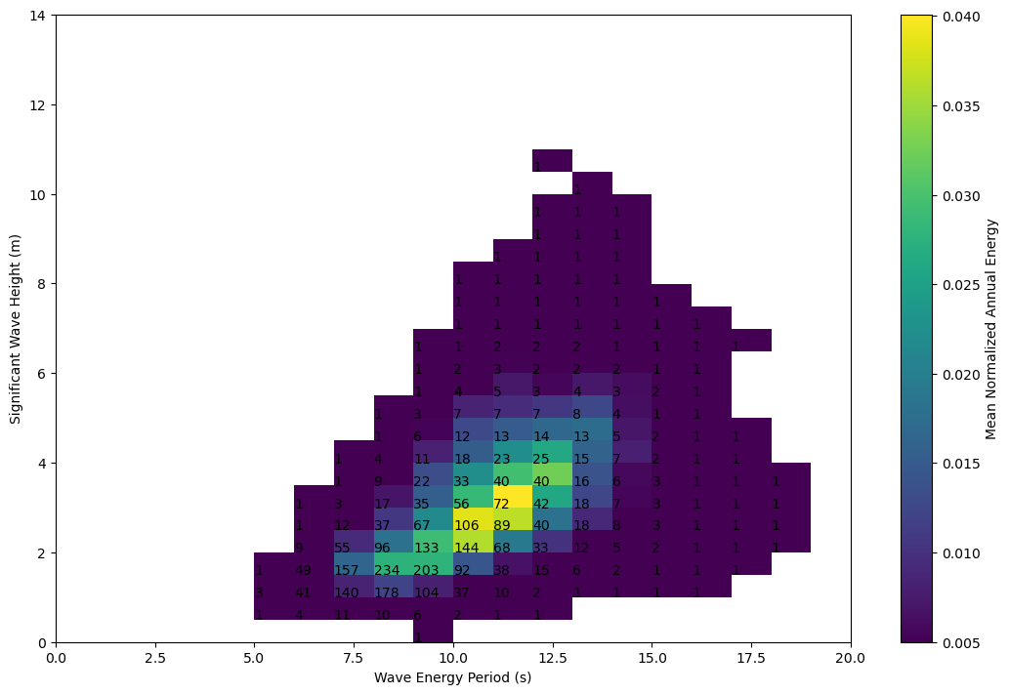
Figure 2.1 – Omni-directional bivariate histogram for PacWave from 1979-2010.

2.1.2 Annual wave Rose
To describe the directional distribution of wave conditions, IEC standards required a wave rose. Figure 2 shows the mean maximum energy flux and mean wave direction conditions at PacWave South. The direction is defined as the direction in which waves are traveling and the wave flux within each sea-state assumes deep-water conditions. The directional bins are broken up into 15° segments while the color contour represents the average annual maximum wave energy transport in a given direction. The primary wave directions at PacWave South are West, South-West with wave resources reaching 60 kW/m.

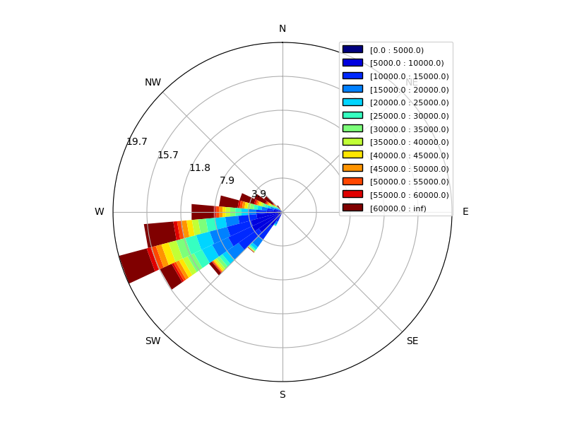
2.1.3 Annual variation of long-term monthly mean
Figure 2.2 – Wave rose distribution of wave energy from 1979-2010 at PacWave South.
Figure 3 shows annual monthly statistics for $H_{m0}$, $T_{e}$, omni-directional wave power, $J$, and the mean maxiumum resolved wave power, $J_{θjmax}$. To clearly describe the temporal and seasonal shifts in parameters, Figure 4a-d show the monthly mean (+/- one standard deviation), the median (50th percentile), and 10th/90th percentiles. Both the significant wave height and energy period vary greatly with the seasons. The average value for $H_{m0}$ in the winter months (November through March) is 2.5-3 m while the average for the summer months (May through September) is around 1.5 m. The average $T_{e}$for the winter months is 11 and 8 s for the summer months. Significant wave height and energy period are both evenly distributed about the mean throughout the year.

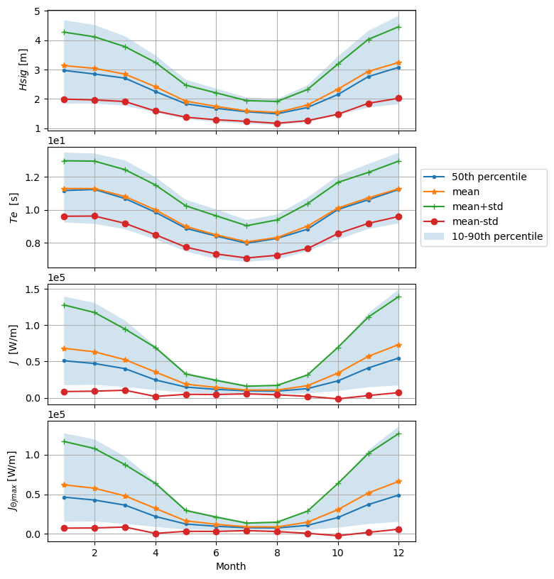
Figure 3 - Mean annual monthly Statistics for the Spectral parameters at PacWave. From top to bottom: (a) Significant wave height, (b) Energy period, (c) Omni-directional wave power, (d) average maximum directionally resolved wave power.
The distribution for the remaining variable in Figure 3 are not as evenly distributed with the parameters varying greater in the winter months than the summer months. In Figure 3c, the maximum average value of Omni-directional wave transport occurs in December at 80 kW/m. The minimums occur in the summer months with the average wave transport values staying below 20 kW/m. The average maximum resolved wave transport is also greatest in December at 70 kW/m. The averages in the summer stay below 20 kW/m.

2.1.4 Extreme Environmental contours
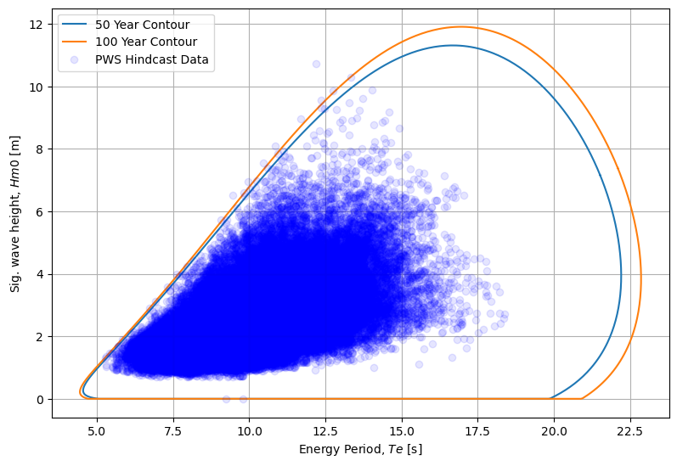
From the Hindcast data, there are a few points that lie completely outside of the two contours for the estimated $H_{m0}$-$T_{e}$ range (Figure 4). The first has a significant wave height of 10.8 m and an energy period of 12.2 s. The second has a significant wave height and energy period of 6.5 m and 9.5 s. The maximum significant wave height and energy period combination for the 50-year return period occur at 11.3 m and 16.9 s respectfully. The 100-year return period has a maximum significant wave height, energy period combination of 11.9 m and 17.1 s. Due to course resolutions among long-term Hindcast models of wind are well recognized for under-estimating extreme conditions. With that being said, the maximums found in this analysis would be considered a conservative estimate.
Figure 4 - Extreme environmental contours associated with 50- and 100-year return periods of sea states represented by significant wave height and energy period. Hindcast measurements include data at 3-hour resolution between 1979 and 2010.

2.1.5 Key resource parameters
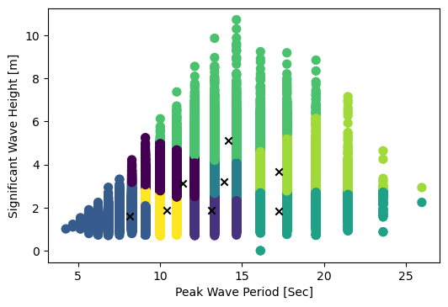
Another useful analysis is finding the K-means clusters of the significant wave height and peak period of the wave conditions. This is not required by IEC standards but is often used in early design stages as a baseline of wave conditions reprehensive of the location. The Hindcast data used in this assessment is modeled after real Hindcast data which is shown in Figure 5. There are gaps of recorded wave periods in the cluster visualization. Unlike buoy data, the modeled Hindcast data only has data for certain wave periods. If buoy data was used in this analysis the gaps would not be present. However, the Hindcast data is analyzed for accuracy whereas buoy data could lead to inconsistencies based on individual buoy sampling differences. For this analysis we choose to find eight clusters that provide representative wave conditions for the site. Each cluster centroid is determined from the density of data points. In this case we are just using two variables – $H_{m0}$ and $T_{e}$ – but N-number of related variables can be clustered using K-means clusters. From these clusters we can find a good representation of operational wave conditions, wave conditions on the breaking edge, and conditions with longer wave periods.
Figure 5 – (a) Table indicating the K-means cluster centroid values. (b) Clustered environmental data grouped into 8 clusters by the K-means algorithm. The parameters are significant wave height (m) and peak wave period (s). Data is taken from DOE’s WPTO US Wave virtual buoy dataset. X-markers indicate the centroid locations within the clusters.

The cluster with the longest wave period has a centroid with a wave height-peak period combo of 2.26 m and 2.46 s respectfully. The most frequent representative wave condition has a cluster density of 19.37 % and a significant wave height-peak period combo of 1.97 m and 11.52 s. Table 1 displays K-means clusters for the Significant wave height, energy period, maximum resolved wave transport, and spectral width as required by IEC TS 62600-101.

Table 1 – PacWave cluster centroid parameter values.

2.2 Wave Energy Testing Site, HI assessment
WETS is the US’s first grid-connected wave energy test site which expanded to 3 testing berths in 2015. The testing facility hosts companies to test their pre-commercial WEC devices in an operational setting. It is run through a cooperative effort between the Navy and US Department of Energy (DOE) with support from of Hawai’i Natural Energy Institute and the Hawai’i National Marine Renewable Energy Center. WETS is located North of Mōkapu Peninsula, Marine Corps Base Hawaii, Kaneohe Bay, O’ahu, Hawai’i. The 60 m and 80 m depth test berths have an installed capacity of 1 MW while the berth with a 30 m depth has a capacity of 250 kW. This assessment includes data from 1979-2010. Data pulled for this assessment uses the coordinates 21°39'1"N 157°47'31"W to complete the assessment using the DOE WPTO US Wave dataset.

2.2.1 Annual histogram of sea state occurrences
Figure 6 shows the bivariate histogram for WETS. Using the Hindcast data we find the most frequent sea state, at 429 hours, has a significant wave height of 1.5 m and an energy period of 6 s.

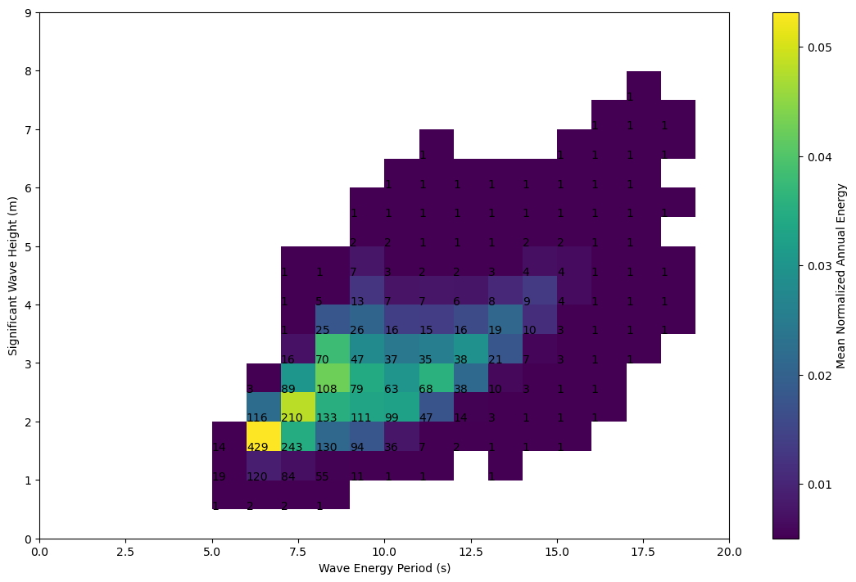
2.2.2 Annual wave Rose
Figure 6 – Omni-directional bivariate histogram for WETS from 1979-2010.
Figure 7 shows the mean maximum energy flux and mean wave direction conditions at WETS. The primary wave directions are North-Northeast, East with wave resources reaching 60 kW/m. There are recorded directions ranging from North to Southwest. The Southwest directions have significantly less occurrences but seem to produce higher wave energy transport given their occurrence amount.

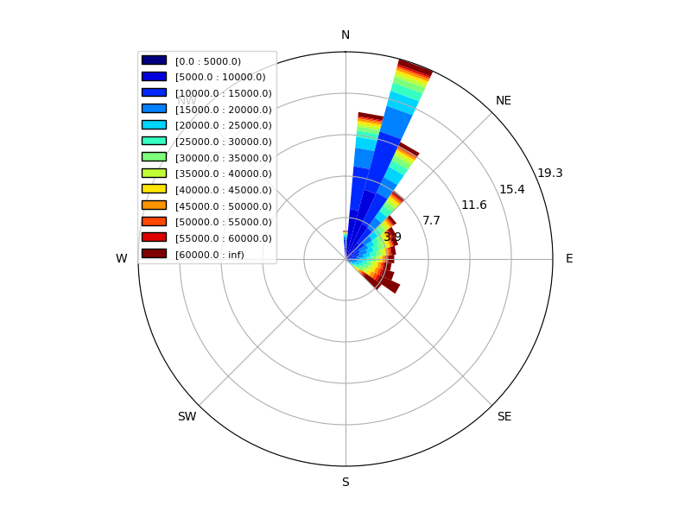
2.2.3 Annual variation of long-term monthly mean
Figure 7 – Wave rose distribution of wave energy from 1979-2010 at WETS.

Figure 8 shows annual monthly statistics for $H_{m0}$, $T_{e}$, omni-directional wave power, $J$, and the mean maxiumum resolved wave power, $J_{θjmax}$ for WETS. Both the significant wave height and energy period vary greatly with the seasons. The average value for $H_{m0}$ in the winter months (November through March) is 2.7 m while the average for the summer months (May through September) is 1.8 m. The average $T_{e}$for the winter months is 10.2 s and 7.4 s for the summer months. Significant wave height and energy period are both evenly distributed about the mean throughout the year.
The distribution for the remaining variable in Figure 8 are not as evenly distributed with the parameters varying greater in the winter months than the summer months. In Figure 8c, the maximum average value of Omni-directional wave transport occurs in January at 52 kW/m. The minimums occur in the summer months with the average wave transport values staying below 10 kW/m. The average maximum resolved wave transport is also greatest in January at 43 kW/m. The averages in the summer stay below 10 kW/m.
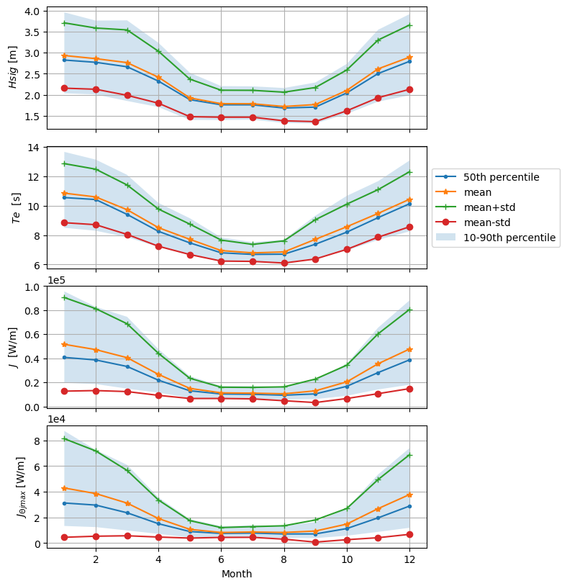
Figure 8 - Mean annual monthly Statistics for the Spectral parameters at WETS. From top to bottom: (a) Significant wave height, (b) Energy period, (c) Omni-directional wave power, (d) average maximum directionally resolved wave power.

2.2.4 Extreme Environmental contours
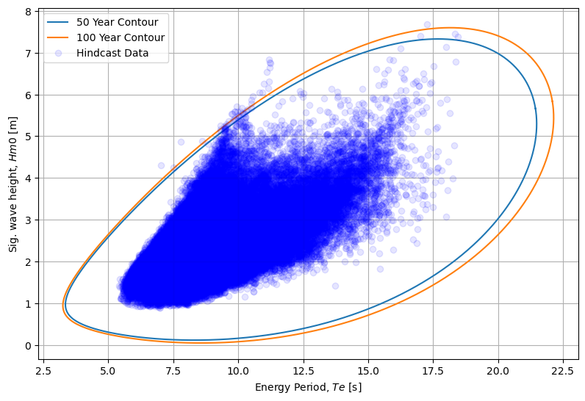
In Figure 9, there are a number of points that lie completely outside of the two extreme contours for the estimated $H_{m0}$-$T_{e}$ range. The majority of these points occur with energy periods around 11 s and signnificant wave heights ranging from 6 to 7 m. The maximum significant wave height and energy period combination for the 50-year return period occur at 7.3 m and 18 s respectfully. The 100-year return period has a maximum significant wave height, energy period combination of 7.6 m and 18.4 s.
Figure 9 - Extreme environmental contours associated with 50- and 100-year return periods of sea states represented by significant wave height and energy period. Hindcast measurements include data at 3-hour resolution between 1979 and 2010.

2.2.5 Key resource parameters
The $H_{m0}$- $T_{e}$ cluster information for WETS is shown in Figure 10. Here the cluster with the longest wave period has a centroid with a wave height-peak period combo of 4.1 m and 16.0 s respectfully. The most frequent representative wave condition has a cluster density of 23.39 % and a significant wave height-peak period combo of 1.69 m and 7.4 s. The IEC required data is found in Table 2.
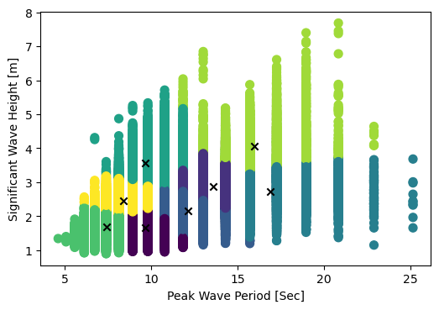
Table 2 – WETS cluster centroid parameter values.

Figure 10 – (a) Table indicating the K-means cluster centroid values. (b) Clustered environmental data grouped into 8 clusters by the K-means algorithm. The parameters are significant wave height (m) and peak wave period (s). Data is taken from DOE’s WPTO US Wave virtual buoy dataset. X-markers indicate the centroid locations within the clusters.

2.3 Molokai, HI assessment
This assessment includes data from 1979-2010. Data pulled for this assessment uses the coordinates 21°16'40.1"N 157°00'13.6"W to complete the assessment using the DOE WPTO US Wave dataset. This site is located 9 km North of the island.

2.3.1 Annual histogram of sea state occurrences
Figure 11 shows the bivariate histogram for Molokai. Using the Hindcast data we find the most frequent sea state, at 419 hours, has a significant wave height of 2 m and an energy period of 7 s. The following highest ranked reoccurring wave conditions have $H_{m0}$ – $T_{e}$ combinations of 1.5 m at 7.5 s and 2 m at 7.5. Both conditions have a frequency of 220 and 219 hours respectively.

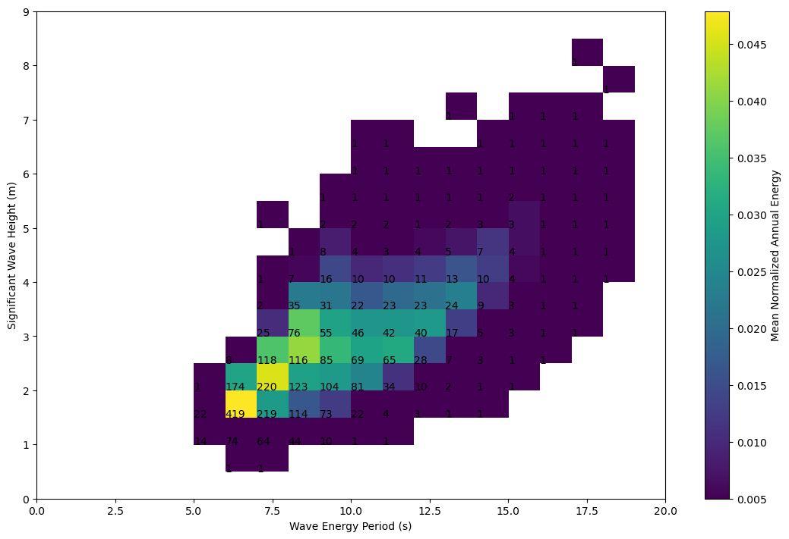
2.3.2 Annual wave Rose
Figure.11 – Omni-directional bivariate histogram for Molokai from 1979-2010.
Figure 12 shows the mean maximum energy flux and mean wave direction conditions at the specific site North of Molokai. The primary wave directions at Molokai are North-Northweast with wave resources reaching 60 kW/m. There are recorded directions ranging from North to Southwest. The Southwest directions have significantly less occurrences but seem to produce higher wave energy transport given their occurrence amount.

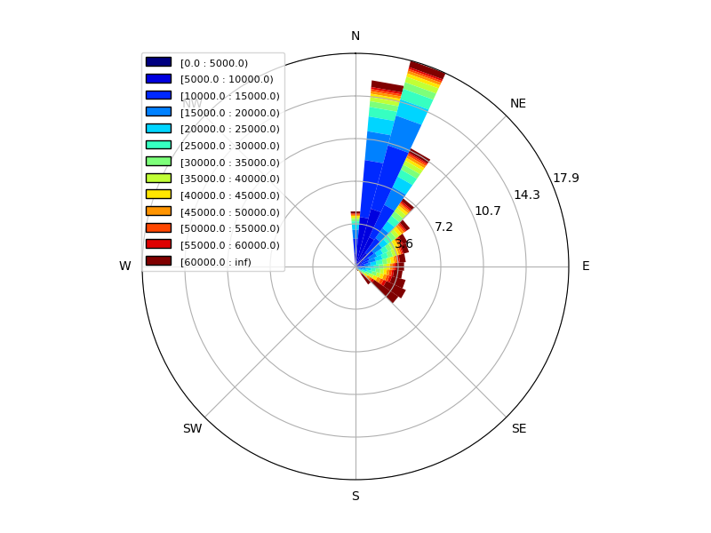
2.3.3 Annual variation of long-term monthly mean
Figure 12 – Wave rose distribution of wave energy from 1979-2010 North of Molokai.

Figure 13 shows annual monthly statistics for $H_{m0}$, $T_{e}$, omni-directional wave power, $J$, and the mean maxiumum resolved wave power, $J_{θjmax}$. Both the significant wave height and energy period vary greatly with the seasons. The average value for $H_{m0}$ in the winter months (November through March) is 2.8 m while the average for the summer months (May through September) is 1.9 m. The average $T_{e}$for the winter months is 10.1 s and 7.0 s for the summer months. Significant wave height and energy period are both evenly distributed about the mean throughout the year.
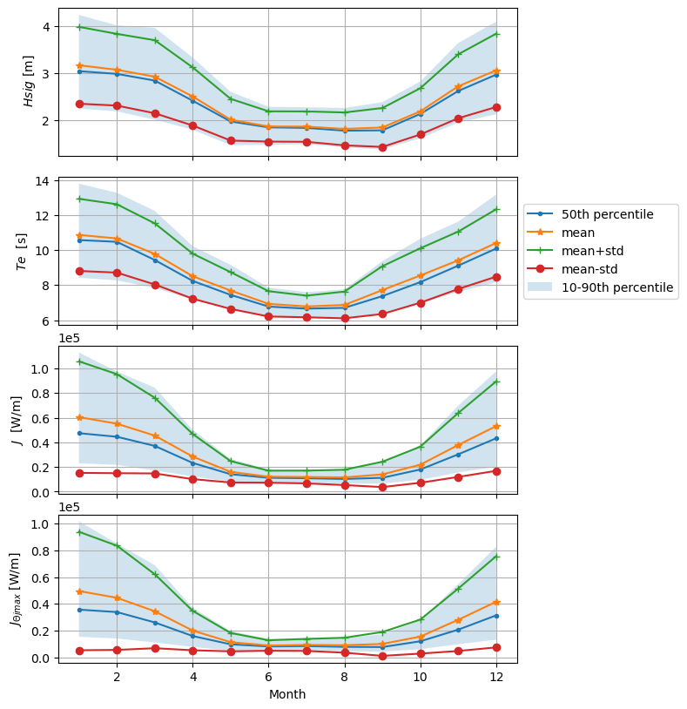
The distribution for the remaining variable in Figure 13 are not as evenly distributed with the parameters varying greater in the winter months than the summer months. In Figure 13c, the maximum average value of Omni-directional wave transport occurs in January at 60 kW/m. The minimums occur in the summer months with the average wave transport values staying below 15 kW/m. The average maximum resolved wave transport is also greatest in January at 50 kW/m. The averages in the summer stay below 10 kW/m.
Figure 13 - Mean annual monthly Statistics for the Spectral parameters for Molokai, HI. From top to bottom: (a) Significant wave height, (b) Energy period, (c) Omni-directional wave power, (d) average maximum directionally resolved wave power.

2.3.4 Extreme Environmental contours
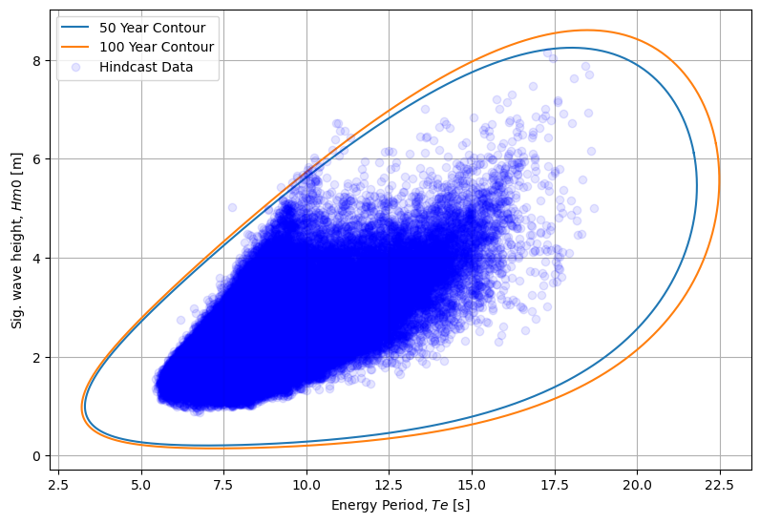
There are a few points that lie completely outside of the two extreme contours for the estimated $H_{m0}$-$T_{e}$ range in Figure 14. The majority of these points occur with energy periods around 11 s and significant wave heights ranging from 6 to 7 m. The maximum significant wave height and energy period combination for the 50-year return period occur at 8.2 m and 18.4 s respectfully. The 100-year return period has a maximum significant wave height, energy period combination of 8.6 m and 18.8 s.
Figure 14 - Extreme environmental contours associated with 50- and 100-year return periods of sea states represented by significant wave height and energy period. Hindcast measurements include data at 3-hour resolution between 1979 and 2010.

2.3.5 Key resource parameters
Figure 15 shows the cluster information for Molokai. The cluster with the longest wave period has a centroid with a wave height-peak period combo of 2.9 m and 18.9 s respectfully. The most frequent representative wave condition has a cluster density of 21.8% and a significant wave height-peak period combo of 1.9 m and 10.4 s. The second cluster with a large frequency has a density of 21.6% with a 1.6 m and 8.2 s significant wave height and peak period combo. Table 3 displays the IEC required data.
Figure 15 – (a) Table indicating the K-means cluster centroid values. (b) Clustered environmental data grouped into 8 clusters by the K-means algorithm. The parameters are significant wave height (m) and peak wave period (s). Data is taken from DOE’s WPTO US Wave virtual buoy dataset. X-markers indicate the centroid locations within the clusters.
Table 3 – Molokai cluster centroid parameter values.

2.4 St. Paul, AK assessment
This assessment includes data from 1985-1990 and 1992-2009. Data pulled for this assessment uses the coordinates 56°16'56"N 171°10'15"W to complete the assessment using the DOE WPTO US Wave dataset. This site is 106 km Southwest of St. Paul Island with a water depth of 2860 m.

2.4.1 Annual histogram of sea state occurrences
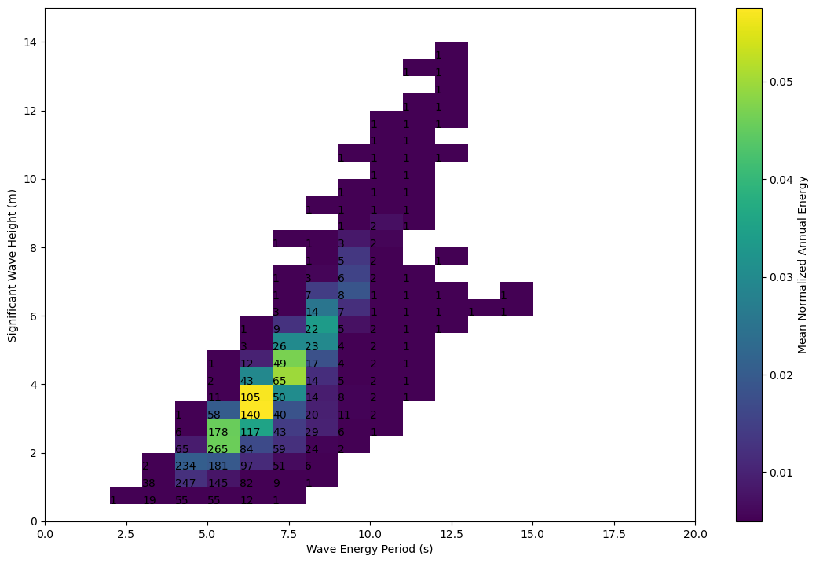
Figure 16 shows the bivariate histogram for St. Paul. Using the Hindcast data we find the most frequent sea state, at 265 hours, has a significant wave height of 2 m and an energy period of 5.5 s. The following highest ranked reoccurring wave conditions have $H_{m0}$ – $T_{e}$ combinations of 1.5 m at 5.0 s and 2 m at 5.0 s. Both conditions have a frequency of 247 and 234 hours respectively.
Figure 16 – Omni-directional bivariate histogram for Southwest of St. Paul, Alaska from 1985-1990 & 1992-2009.

2.4.2 Annual wave Rose
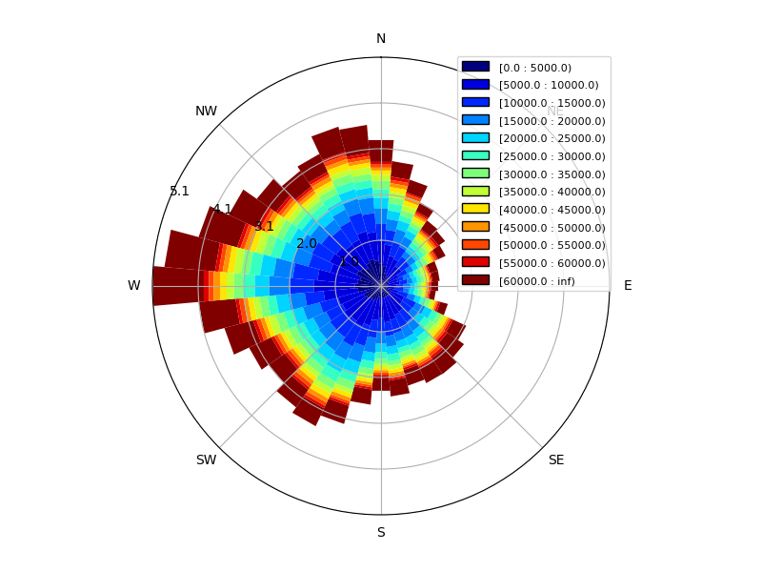
Figure 17 shows the mean maximum energy flux and mean wave direction conditions. Compared to other locations of interest, the site used for the St. Paul location is in open ocean conditions in the Bering Sea. The direction with the largest occurrence is waves propagating West of the site, however this location in particular experiences waves in all directions to some degree. All directions also have average max energy transport values of 60 kW but waves from the West have the highest average max energy transport.
Figure 17 – Wave rose distribution of wave energy from 1985-1991 and 1992-2009 Southwest of St. Paul.

2.4.3 Annual variation of long-term monthly mean
Figure 18 shows annual monthly statistics for $H_{m0}$, $T_{e}$, omni-directional wave power, $J$, and the mean maxiumum resolved wave power, $J_{θjmax}$. Both the signigicant wave height and energy period vary greatly with the seasons. The average value for $H_{m0}$ in the winter months (November through March) is 2.9 m while the average for the summer months (May through September) is 2.0 m. The average $T_{e}$for the winter months is 10.1 s and 7.0 s for the summer months. Significant wave height and energy period are both evenly distributed about the mean throughout the year.
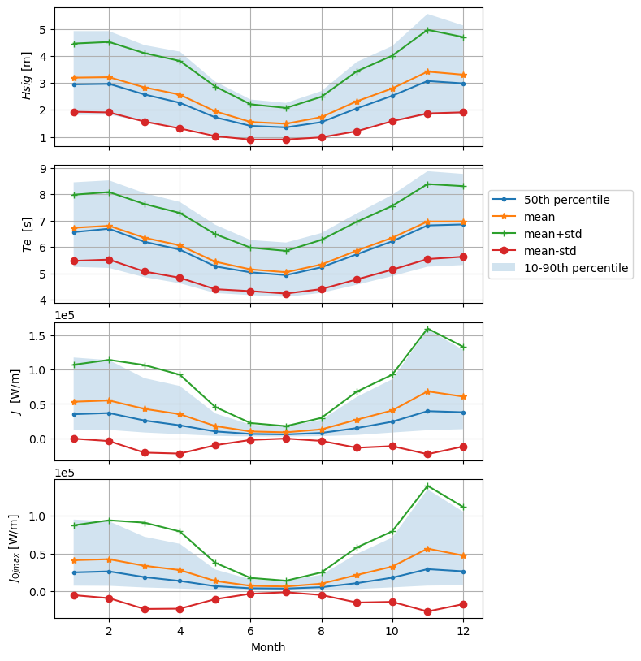
Figure 18 - Mean annual monthly Statistics for the Spectral parameters for St. Paul, Alaska. From top to bottom: (a) Significant wave height, (b) Energy period, (c) Omni-directional wave power, (d) average maximum directionally resolved wave power.
The distribution for the remaining variable in Figure 18 are not as evenly distributed with the parameters varying greater in the winter months than the summer months. In Figure 18c, the maximum average value of Omni-directional wave transport occurs in January at 60 kW/m. The minimums occur in the summer months with the average wave transport values staying below 15 kW/m. The average maximum resolved wave transport is also greatest in January at 50 kW/m. The averages in the summer stay below 10 kW/m.

2.4.4 Extreme Environmental contours
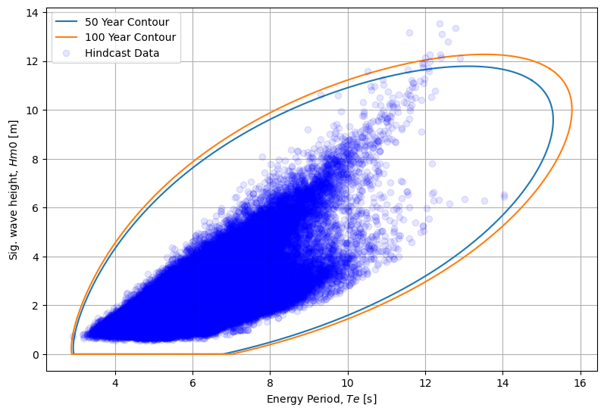
The Hindcast data for St. Paul has a few points that lie completely outside of the two extreme contours for the estimated $H_{m0}$-$T_{e}$ range. Looking at Figure 19, the majority of these points occur with energy periods around 11 s and significant wave heights ranging from 6 to 7 m. The maximum significant wave height and energy period combination for the 50-year return period occur at 11.8 m and 13.4 s respectfully. The 100-year return period has a maximum significant wave height, energy period combination of 12.3 m and 13.7 s.
Figure 19 - Extreme environmental contours associated with 50- and 100-year return periods of sea states represented by significant wave height and energy period. Hindcast measurements include data at 3-hour resolution for 1985-1992 & 1992-2009.

2.4.5 Key resource parameters
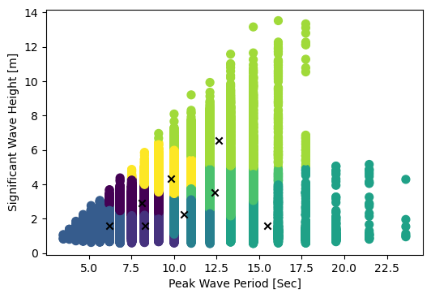
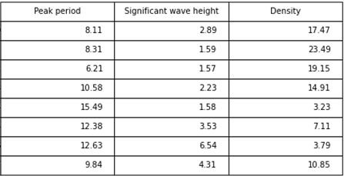
In Figure 20, the cluster with the longest wave period has a centroid with a wave height-peak period combo of 2.9 m and 18.9 s respectfully. The most frequent representative wave condition has a cluster density of 21.6% and a significant wave height-peak period combo of 1.6 m and 8.2 s. Table 4 shows the IEC required data with K-means clusters.
Figure 20 – (a) Table indicating the K-means cluster centroid values. (b) Clustered environmental data grouped into 8 clusters by the K-means algorithm. The parameters are significant wave height (m) and peak wave period (s). Data is taken from DOE’s WPTO US Wave virtual buoy dataset. X-markers indicate the centroid locations within the clusters.
Table 4 – St. Paul cluster centroid parameter values.

2.5 Yakutat, AK assessment
This assessment includes data from 1985-1990 and 1992-2009. Data pulled for this assessment uses the coordinates 59°34'44"N 139°52'27"W to complete the assessment using the DOE WPTO US Wave dataset. The assessment location is 9 km Northwest of Yakutat with a water depth of 145 m.

2.5.1 Annual histogram of sea state occurrences
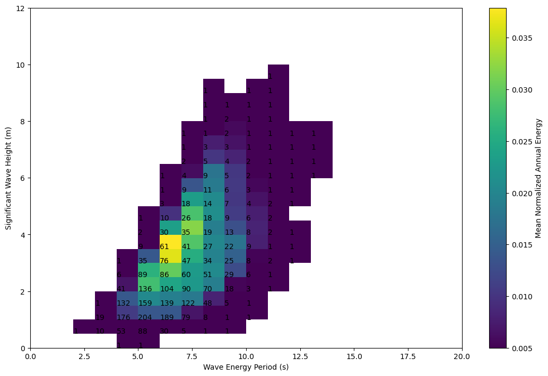
Figure 21 shows the bivariate histogram where the resolution of $H_{m0}$ is 0.5 m and $T_{e}$ is 1 s. Using the Hindcast data we find the most frequent sea state, at 204 hours, has a significant wave height of 1.5 m and an energy period of 5 s. The following highest ranked reoccurring wave conditions have $H_{m0}$ – $T_{e}$ combinations of 1.5 m at 4.5 s and 1.5 m at 6 s. Both conditions have a frequency of 189 and 176 hours respectively.
Figure 21 – Omni-directional bivariate histogram for Northwest of Yakutat, Alaska from 1985-1990 & 1992-2009.

2.5.2 Annual wave Rose
Figure 22 shows the mean maximum energy flux and mean wave direction conditions at the site Northwest of Yakutat. The primary wave directions at Yakutat are Southwest, South, and Southeast with wave resources reaching 60 kW/m. All directional bins have the wave transport reach 60 kW/m, however, the North-Northeast directions have more occurrences reaching that threshold than North-Northwest.
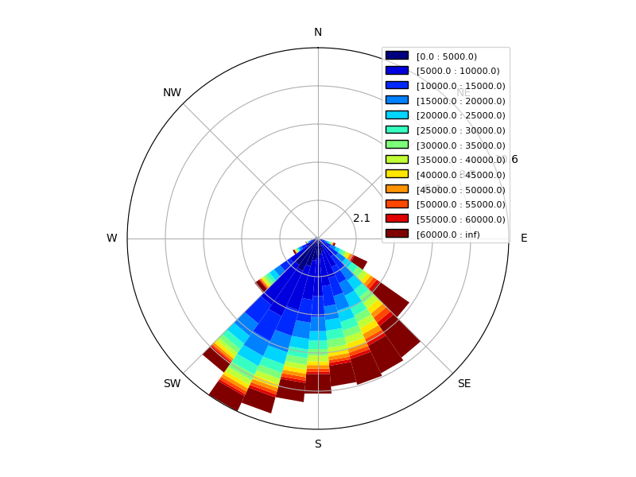
Figure 22 – Wave rose distribution of wave energy from 1985-1991 and 1992-2009 North of Yakutat.

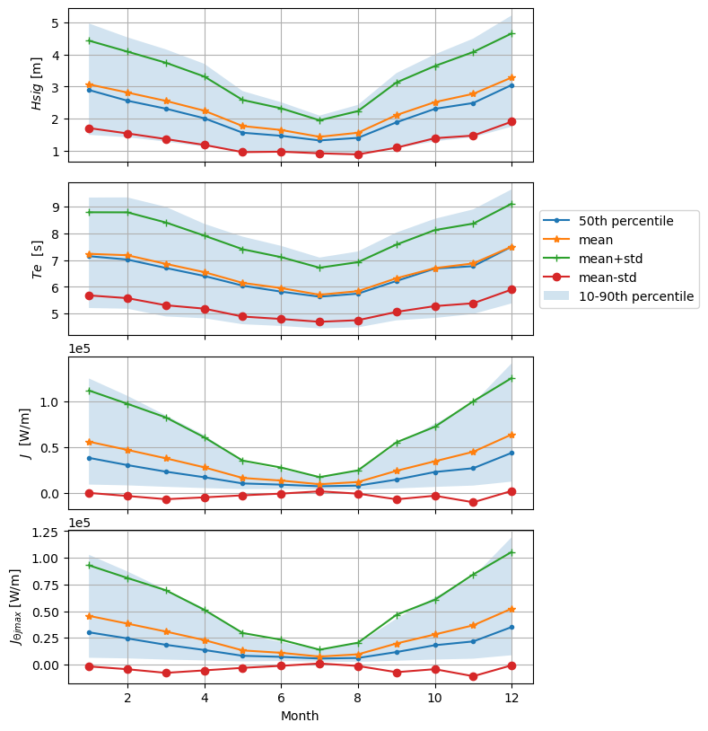
Figure 23 - Mean annual monthly Statistics for the Spectral parameters for Yakutat, Alaska. From top to bottom: (a) Significant wave height, (b) Energy period, (c) Omni-directional wave power, (d) average maximum directionally resolved wave power.

2.5.3 Annual variation of long-term monthly mean
Figure 23 shows annual monthly statistics for $H_{m0}$, $T_{e}$, omni-directional wave power, $J$, and the mean maxiumum resolved wave power, $J_{θjmax}$ for Yakutat. Both the signigicant wave height and energy period vary greatly with the seasons. The average value for $H_{m0}$ in the winter months (November through March) is 2.75 m while the average for the summer months (May through September) is 1.7 m. The average $T_{e}$for the winter months is 7.25 s and 6.0 s for the summer months. Significant wave height and energy period are both evenly distributed about the mean throughout the year.
The distribution for the remaining variable in Figure 23 are not as evenly distributed with the parameters varying greater in the winter months than the summer months. In Figure 23c, the maximum average value of omni-directional wave transport occurs in January at 60 kW/m. The minimums occur in the summer months with the average wave transport values staying below 15 kW/m. The average maximum resolved wave transport is also greatest in January at 50 kW/m. The averages in the summer stay below 10 kW/m.

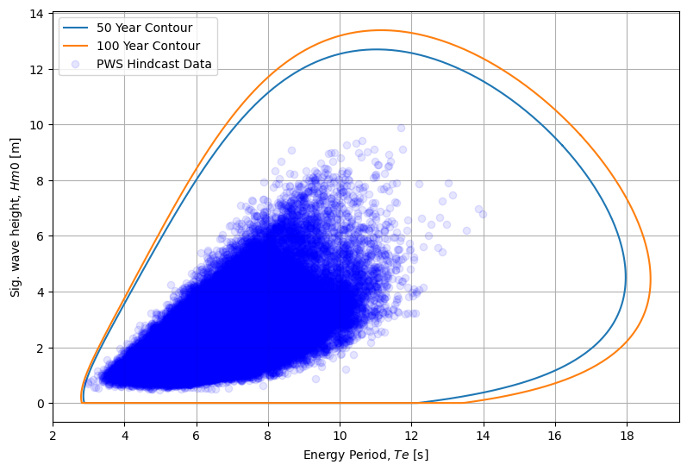
2.5.4 Extreme Environmental contours
Figure 24 - Extreme environmental contours associated with 50- and 100-year return periods of sea states represented by significant wave height and energy period. Hindcast measurements include data at 3-hour resolution between 1979 and 2010.

In Figure 24, the maximum significant wave height and energy period combination for the 50-year return period occur at 12.7 m and 11.2 s respectfully. The 100-year return period has a maximum significant wave height, energy period combination of 13.4 m and 11.3 s.

2.5.5 Key resource parameters
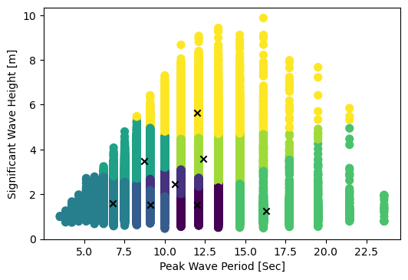
Figure 25 shows the cluster data for Yakutat. Here the cluster with the longest wave period has a centroid with a wave height-peak period combo of 1.2 m and 16.3 s respectfully. The most frequent representitive wave condition has a cluster density of 26.6% and a significant wave height-peak period combo of 1.5 m and 9.0 s. Table 5 displays the clusters of IEC required data.
Table 5 – Yakutat cluster centroid parameter values.

Figure 25 – (a) Table indicating the K-means cluster centroid values. (b) Clustered environmental data grouped into 8 clusters by the K-means algorithm. The parameters are significant wave height (m) and peak wave period (s). Data is taken from DOE’s WPTO US Wave virtual buoy dataset. X-markers indicate the centroid locations within the clusters.

2.6 Sebastian, FL assessment
This assessment includes data from 1979-2010. Data pulled for this assessment uses the coordinates 27°55'51.8"N 79°46'17.0"W to complete the assessment using the DOE WPTO US Wave dataset. The coordinate for this assessment is located 65 km East of Sebastian with a water depth of 376 m.

2.6.1 Annual histogram of sea state occurrences
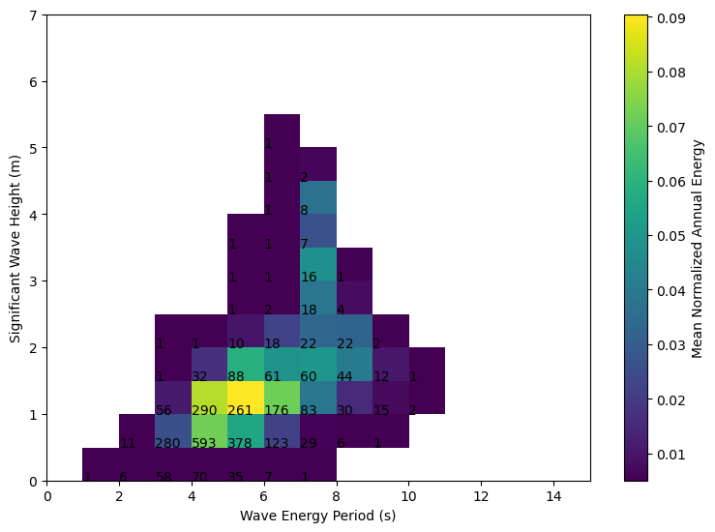
Figure 26 shows the bivariate histogram for Sebastian. Using the Hindcast data we find the most frequent sea state, at 593 hours, has a significant wave height of 1 m and an energy period of 4.5 s. The following highest ranked reoccurring wave conditions have $H_{m0}$ – $T_{e}$ combinations of 1 m at 5 s and 1.5 m at 4.5 s. Both conditions have a frequency of 378 and 290 hours respectively.
Figure 26 – Omni-directional bivariate histogram for Sebastian, FL from 1979-2010.

2.6.2 Annual wave Rose
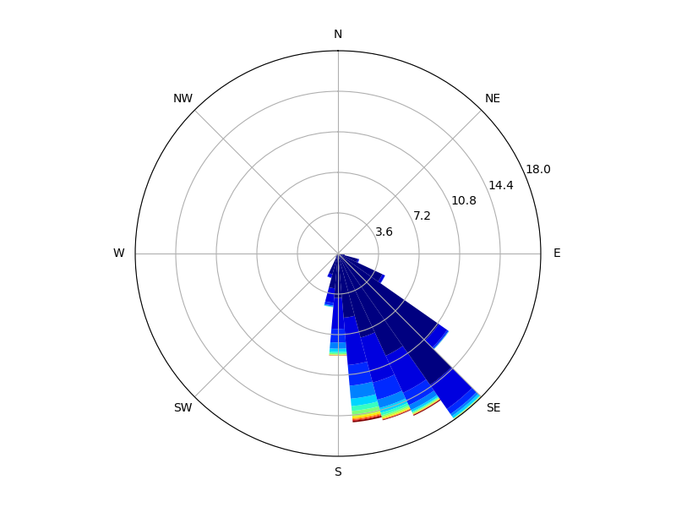
Figure 27 shows the mean maximum energy flux and mean wave direction conditions at the site east of Sebastian. The primary wave direction at the location East of Sebastian is Southeast with wave resources primarily staying under 20 kW/m. The wave resource is unimodal here with wave directions ranging from East to South. The East Coast produces significantly less wave power than the West Coast so the outputs for the wave rose are as expected. The maximum resolved wave transport does exceed 20 kW/m in most wave directions, however, the occurrences of waves exceeding 30 kW/m is low.
Figure 27 – Wave rose distribution of wave energy from 1979-2010 East of Sebastian.

2.6.3 Annual variation of long-term monthly mean
Figure 28 shows annual monthly statistics for Sebastian, FL. Both the signigicant wave height and energy period vary greatly with the seasons. The average value for $H_{m0}$ in the winter months (November through March) is 1.1 m while the average for the summer months (May through September) is 0.8 m. The average $T_{e}$for the winter months is 5.5 s and 5.0s for the summer months. Significant wave height has slightly lower distribution in the summer months compared to the winter months where the winter months vary more.Peak period has an equal distribution throughout the year.
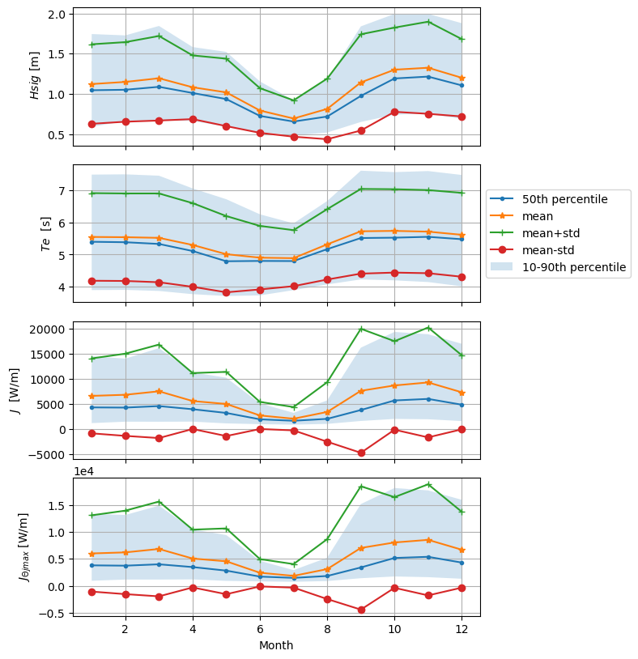
Figure 28 - Mean annual monthly Statistics for the Spectral parameters for Sebastian, FL. From top to bottom: (a) Significant wave height, (b) Energy period, (c) Omni-directional wave power, (d) average maximum directionally resolved wave power.
The distribution for the remaining variable in Figure 28 are not as evenly distributed with the parameters varying greater in the winter months than the summer months. In Figure 28c, the maximum average value of omni-directional wave transport occurs in November with 5.5 kW/m. The minimums occur in the summer months with the average wave transport values staying below 5 kW/m. The average maximum resolved wave transport is also greatest in November at 5 kW/m. The averages in the summer stay below 1 kW/m.

2.6.4 Extreme Environmental contours
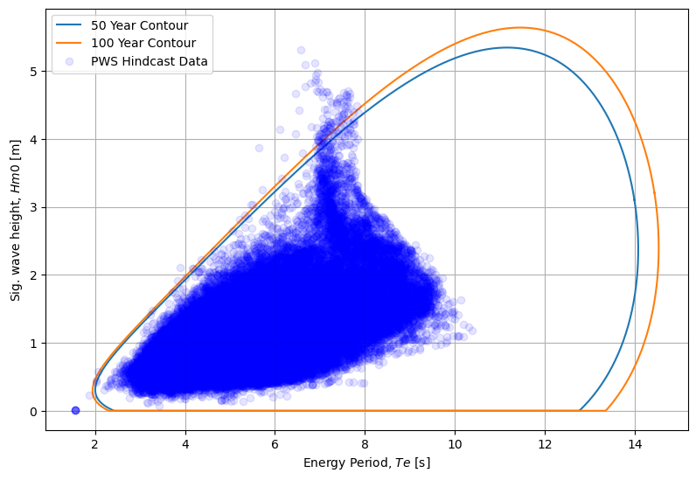
Figure 29 displays the extreme contours for the location. Compared to other locations, this site has far more points lying outside of the extreme contours for the the estimated $H_{m0}$-$T_{e}$ range. The majority of these points occur with energy periods 6-8 s and signnificant wave heights ranging from 4- 5 m. There also is a group of points with low wave period and a wave height close of 0 m. This was common in locations near the chosen site with very low wave heights. The maximum significant wave height and energy period combination for the 50-year return period occur at 5.3 m and 11.4 s respectfully. The 100-year return period has a maximum significant wave height, energy period combination of 5.6 m and 11.5 s.
Figure 29 - Extreme environmental contours associated with 50- and 100-year return periods of sea states represented by significant wave height and energy period. Hindcast measurements include data at 3-hour resolution between 1979 and 2010.

2.6.5 Key resource parameters
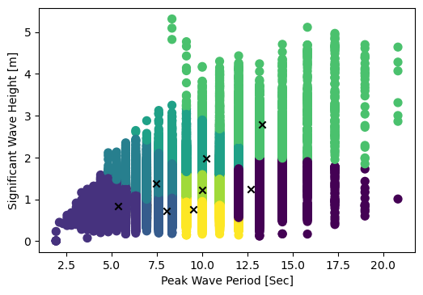
Figure 30 displays the cluster information for Sebastian. The cluster with the longest wave period has a centroid with a wave height-peak period combo of 2.8 m and 13.3 s respectfully. However, as shown in Figure 30, wave periods in this region can be upwards of 20 s. The most frequent representitive wave condition has a cluster density of 23.5% and a significant wave height-peak period combination of 0.8 m and 9.5 s. Table 6 displays the IEC required data grouped using kmeans clustering.
Figure 30 – (a) Table indicating the K-means cluster centroid values. (b) Clustered environmental data grouped into 8 clusters by the K-means algorithm. The parameters are significant wave height (m) and peak wave period (s). Data is taken from DOE’s WPTO US Wave virtual buoy dataset. X-markers indicate the centroid locations within the clusters.
Table 5 – Sebastian cluster centroid parameter values.

3 References
[1] DOE's Water Power Technology Office's (WPTO) US Wave dataset was accessed on DATE from https://registry.opendata.aws/wpto-pds-us-wave.
[2] Z. Yang and V. S. Neary, “High-resolution hindcasts for U.S. wave energy resource characterization,” Int. Mar. Energy J., vol. 3, no. 2, pp. 65–71, Sep. 2020.
[3] S. Ahn, V. S. Neary, M. N. Allahdadi, and R. He, “Nearshore wave energy resource characterization along the East Coast of the United States,” Renew. Energy, vol. 172, pp. 1212–1224, Jul. 2021.
[4] K. Klise et al., “MHKiT (Marine and Hydrokinetic Toolkit) - Python.” Jan-2020.

